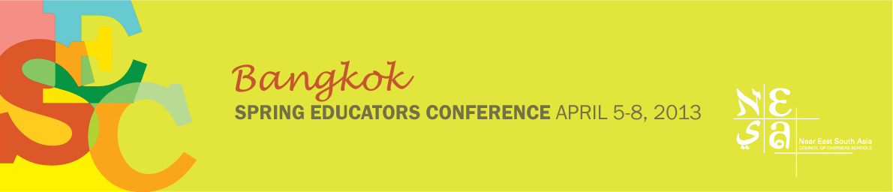

SIGN-UP

Five-Day “Critical Friends” Training Institute at the Spring Educators Conference

If your school would like to reserve places in the “Critical Friends” Training Institute (five days: April 4-8), please complete this form and email it to Aristea Evangelou at the NESA Center: conferences@nesacenter.org. This will reserve places for individual team members in the course. (NB: Aristea will forward your school’s team leader a link to an online registration form, which each team member should then complete.)

This form needs to be signed by a school administrator (e.g., the school head, principal, curriculum coordinator).

Course fee per person: Regular Member - US $825 / Associate Member - $950 (includes coffee breaks, three lunches and Spring Educators Conference social events.)

+++++++++++++++++

NAME OF SCHOOL: _____________________________________________________

Please list the names of members of your school’s team:
Name | Position (e.g., teacher, principal)
1.
2.
3.
4.
5.
6.
7.
8.

Who will be the lead person for your school for this course? (Please provide her/his name and email address)

“Good Faith” agreement: Team members agree to do any necessary preparatory work and come to the course ready to work collaboratively.

Administrator: _________________________________________________

Date Submitted: _________________________________________________

