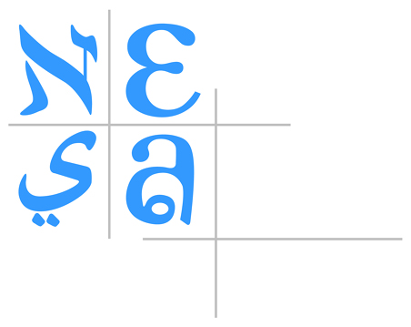

NESA Collaboration Grants

NESA believes in collaboration; is it the cornerstone of our success. In this spirit, NESA provides micro-grants of up to $3000 in support of sustainable collaborative projects among NESA Member schools, projects that focus on increasing professional effectiveness in improving student learning. (NB: the amount awarded will depend, in part, on the number of NESA schools involved.)

Applying for a NESA grant is simple. The head of the lead school in the collaboration must answer the questions below and submit this information to the NESA Center. The application will be forwarded to the Professional Development Advisory Committee (PDAC) for their study and recommendation. NESA’s executive director then makes the final decision.

Application
1. Describe the professional collaboration this grant would support

2. Describe how this collaboration addresses one or more of the following areas of focus:
- Assessment: using data to improve student learning
- Curriculum: programmatic efforts in support of improved student learning (e.g., UbD, mapping, learning continuums)
- Instruction: research-supported teaching strategies which improve student learning
- Leadership: leadership strategies supportive of sustained, systemic standards-based professional development
- Collaboration: building and sustaining inter-school professional collaborations which focus on student learning
- Content: deepening teacher understanding of content knowledge

3. Describe success indicators for this collaboration

4. Note the targeted time-frame for this collaboration/event

5. List participating NESA member schools

Signature:___________________________________ Date: _______________

NOTE: If a grant is awarded, the school receiving the grant agrees to submit an article about the collaboration (500-750 words) for publication by NESA and/or posting on the NESA website; and provide photos of the event for posting on the NESA website.

